Irregular Hexagonal Pyramid
# Source: AI Source: Provided by: [Data Path: Persons Table -> ID Column: 1, Name_En Column: Motasem Essam] -> From: [ChatGPT] on [7/25/2026]
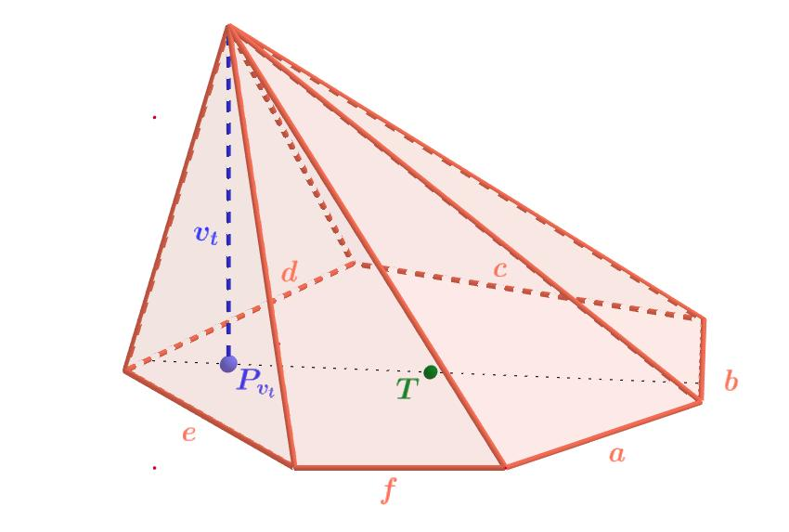
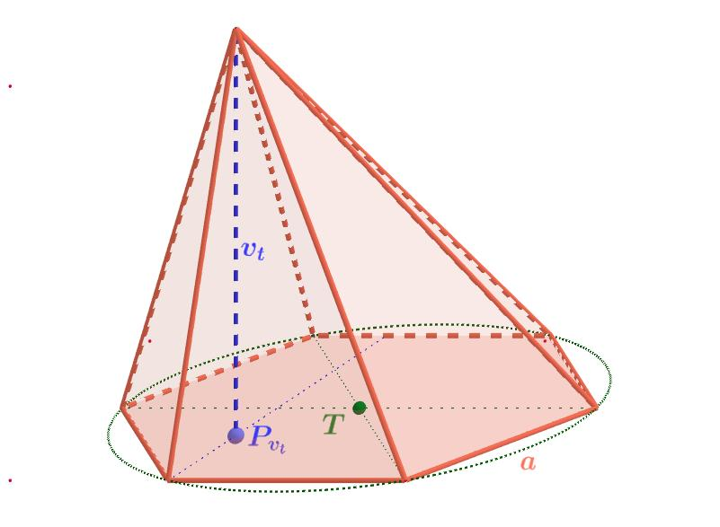

Definition
# Source: AI Source: Provided by: [Data Path: Persons Table -> ID Column: 1, Name_En Column: Motasem Essam] -> From: [ChatGPT] on [7/25/2026]
An irregular hexagonal pyramid is a three-dimensional geometric solid with an irregular hexagonal base and six triangular lateral faces that meet at a single point called the apex.
An irregular hexagon is a six-sided polygon whose sides or interior angles are not all equal. Consequently, the base may have unequal side lengths, unequal angles, or both. The six lateral faces are not necessarily congruent, and their areas may differ.
An irregular hexagonal pyramid can be right or oblique, depending on the position of its apex relative to the designated center of the base. The term irregular describes the base shape; it does not, by itself, determine the pyramid's spatial orientation.

Simple Definition
# Source: AI Source: Provided by: [Data Path: Persons Table -> ID Column: 1, Name_En Column: Motasem Essam] -> From: [ChatGPT] on [7/25/2026]
An irregular hexagonal pyramid is a pyramid with an uneven six-sided base and six triangular side faces that meet at one apex.

Key Characteristics
# Source: AI Source: Provided by: [Data Path: Persons Table -> ID Column: 1, Name_En Column: Motasem Essam] -> From: [ChatGPT] on [7/25/2026]
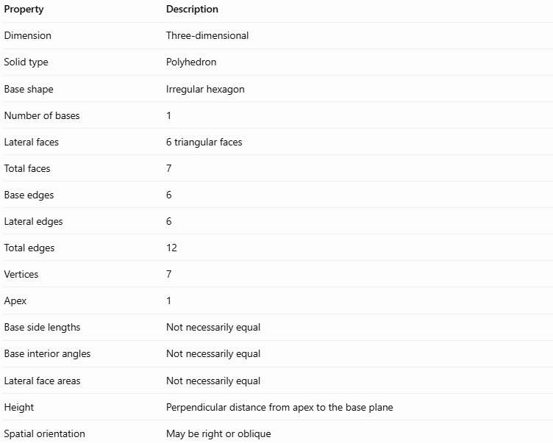
Property | Description
Dimension | Three-dimensional
Solid type | Polyhedron
Base shape | Irregular hexagon
Number of bases | 1
Lateral faces | 6 triangular faces
Total faces | 7
Base edges | 6
Lateral edges | 6
Total edges | 12
Vertices | 7
Apex | 1
Base side lengths | Not necessarily equal
Base interior angles | Not necessarily equal
Lateral face areas | Not necessarily equal
Height | Perpendicular distance from apex to the base plane
Spatial orientation | May be right or oblique
An irregular hexagon still has six sides, and the sum of its interior angles is:
$$\left(6-2\right)×{180}^{∘}={720}^{∘}$$
This remains true whether the hexagon is regular or irregular, provided it is a simple, non-self-intersecting hexagon.

Geometric Representation
# Source: AI Source: Provided by: [Data Path: Persons Table -> ID Column: 1, Name_En Column: Motasem Essam] -> From: [ChatGPT] on [7/25/2026]
The main components are:
- Irregular hexagonal base: The six-sided polygon at the bottom, with sides or angles that are not all equal.
- Apex: The point where the six lateral faces meet.
- Base edges: The six edges forming the hexagonal base.
- Lateral edges: The six line segments connecting the apex to the six base vertices.
- Lateral faces: Six triangular faces, which may differ in shape and area.
- Height ($h$): The perpendicular distance from the apex to the plane containing the base.
- Slant heights: The perpendicular altitudes of the individual lateral triangles. These are not necessarily equal.

Mathematical Representations and Formulas
# Source: AI Source: Provided by: [Data Path: Persons Table -> ID Column: 1, Name_En Column: Motasem Essam] -> From: [ChatGPT] on [7/25/2026]
Let:
- $s_{1},s_{2},…,s_{6}$ = base side lengths
- $p$ = base perimeter
- $B$ = base area
- $h$ = perpendicular height
- $A_{i}$ = area of the $i$-th lateral triangular face
- $l_{i}$ = perpendicular altitude of the $i$-th lateral face
- $A_{L}$ = lateral surface area
- $A_{T}$ = total surface area
- $V$ = volume

A. Base perimeter
# Source: AI Source: Provided by: [Data Path: Persons Table -> ID Column: 1, Name_En Column: Motasem Essam] -> From: [ChatGPT] on [7/25/2026]
The perimeter is the sum of the six base side lengths:
$$\boxed{p=\sum_{i=1}^{6}{s_{i}}}$$
Or, expanded:
$$p=s_{1}+s_{2}+s_{3}+s_{4}+s_{5}+s_{6}$$
Unlike a regular hexagon, the perimeter cannot generally be calculated as $6a$ using one common side length.

B. Base area
# Source: AI Source: Provided by: [Data Path: Persons Table -> ID Column: 1, Name_En Column: Motasem Essam] -> From: [ChatGPT] on [7/25/2026]
An irregular hexagon can be divided into four triangles by drawing diagonals from one vertex to the three non-adjacent vertices that divide it into four triangular regions.
$$\boxed{B=A_{1}+A_{2}+A_{3}+A_{4}}$$
The triangle areas can be calculated using:
$$A_{i}=\frac{1}{2}b_{i}h_{i}$$
Alternatively, if the coordinates of the six base vertices are known, the shoelace formula can be used.

C. Volume
# Source: AI Source: Provided by: [Data Path: Persons Table -> ID Column: 1, Name_En Column: Motasem Essam] -> From: [ChatGPT] on [7/25/2026]
The volume formula applies to both regular and irregular pyramids:
$$\boxed{V=\frac{1}{3}Bh}$$
Here, $B$ is the actual area of the irregular hexagonal base, and $h$ is the perpendicular height.

D. Lateral surface area
# Source: AI Source: Provided by: [Data Path: Persons Table -> ID Column: 1, Name_En Column: Motasem Essam] -> From: [ChatGPT] on [7/25/2026]
Each lateral face is a triangle, so its area is:
$$A_{i}=\frac{1}{2}{}_{si}l_{i}$$
Adding the six triangular faces gives:
$$\boxed{A_{L}=\frac{1}{2}\sum_{i=1}^{6}{s_{i}}l_{i}}$$
The simplified formula $A_{L}=\frac{1}{2}pl$ is valid only when a common slant height $l$ applies to all six faces. That condition should not be assumed for an irregular hexagonal pyramid.

E. Total surface area
# Source: AI Source: Provided by: [Data Path: Persons Table -> ID Column: 1, Name_En Column: Motasem Essam] -> From: [ChatGPT] on [7/25/2026]
The total surface area includes the base and all six lateral faces:
$$\boxed{A_{T}=B+A_{L}}$$

F. Euler's formula
# Source: AI Source: Provided by: [Data Path: Persons Table -> ID Column: 1, Name_En Column: Motasem Essam] -> From: [ChatGPT] on [7/25/2026]
For a convex irregular hexagonal pyramid:
$$V_{e}-E+F=2$$
Substituting the numbers of vertices, edges, and faces:
$$7-12+7=2$$
Euler's formula is satisfied, just as it is for a regular hexagonal pyramid.

Worked Examples
# Source: AI Source: Provided by: [Data Path: Persons Table -> ID Column: 1, Name_En Column: Motasem Essam] -> From: [ChatGPT] on [7/25/2026]
Example 1: Calculating the base perimeter
Suppose an irregular hexagonal base has side lengths of $3,5,4,6,7,$ and $5$ cm.
$$p=3+5+4+6+7+5$$
$$\boxed{p=30\text{ cm}}$$
The sides are unequal, but the perimeter is still the sum of all six sides.
Example 2: Calculating the volume
Suppose an irregular hexagonal pyramid has a base area of $54{\text{ cm}}^{2}$ and a perpendicular height of $10\text{ cm}$.
Using the volume formula:
$$V=\frac{1}{3}Bh$$
Substitute the values:
$$V=\frac{1}{3}\left(54\right)\left(10\right)$$
$$\boxed{V=180{\text{ cm}}^{3}}$$
The irregularity of the base does not change the volume formula.
Example 3: Calculating lateral and total surface area
Suppose the six lateral triangular faces have the following areas:
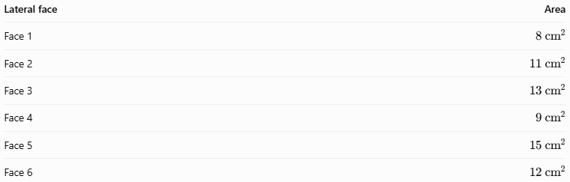
Lateral face | Area
Face 1 | $$8{\text{ cm}}^{2}$$
Face 2 | $$11{\text{ cm}}^{2}$$
Face 3 | $$13{\text{ cm}}^{2}$$
Face 4 | $$9{\text{ cm}}^{2}$$
Face 5 | $$15{\text{ cm}}^{2}$$
Face 6 | $$12{\text{ cm}}^{2}$$
The lateral surface area is the sum of all six areas:
$$A_{L}=8+11+13+9+15+12$$
$$\boxed{A_{L}=68{\text{ cm}}^{2}}$$
If the base area is $54{\text{ cm}}^{2}$, the total surface area is:
$$A_{T}=B+A_{L}$$
$$A_{T}=54+68$$
$$\boxed{A_{T}=122{\text{ cm}}^{2}}$$

Comparison with Related Concepts
# Source: AI Source: Provided by: [Data Path: Persons Table -> ID Column: 1, Name_En Column: Motasem Essam] -> From: [ChatGPT] on [7/25/2026]
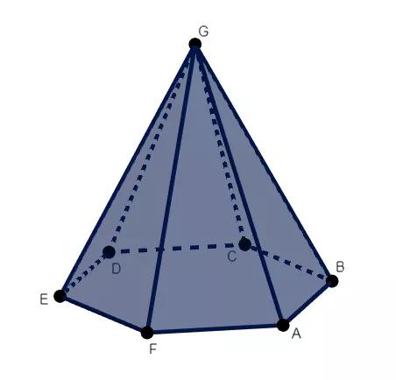
Regular Hexagonal Pyramid
Has a regular hexagonal base and a centered apex. All six lateral faces are congruent isosceles triangles.
Irregular Hexagonal Pyramid
Has an irregular hexagonal base. Its base sides, angles, and lateral face areas are not necessarily equal.
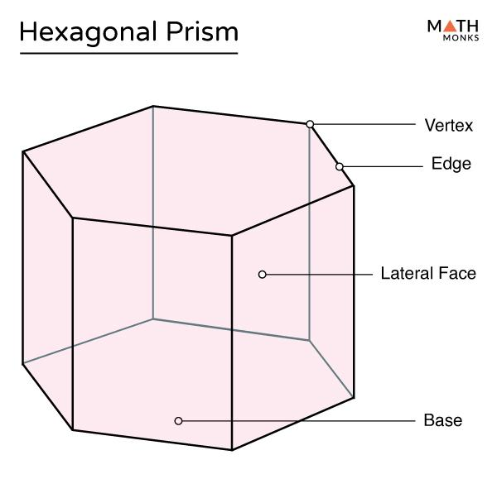
Hexagonal Prism
Has two parallel, congruent hexagonal bases and six lateral faces. It has no single apex.
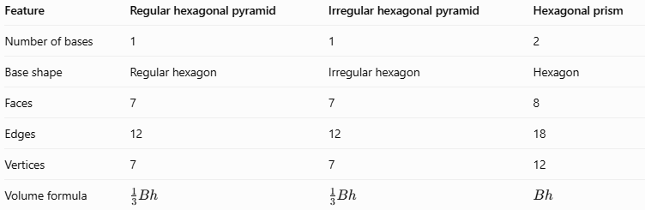
Feature | Regular hexagonal pyramid | Irregular hexagonal pyramid | Hexagonal prism
Number of bases | 1 | 1 | 2
Base shape | Regular hexagon | Irregular hexagon | Hexagon
Faces | 7 | 7 | 8
Edges | 12 | 12 | 18
Vertices | 7 | 7 | 12
Volume formula | $$\frac{1}{3}Bh$$ | $$\frac{1}{3}Bh$$ | $$Bh$$

Applications
# Source: AI Source: Provided by: [Data Path: Persons Table -> ID Column: 1, Name_En Column: Motasem Essam] -> From: [ChatGPT] on [7/25/2026]
- Architecture: Designing asymmetrical roofs, decorative structures, and tapered features.
- Packaging: Creating custom containers with six-sided, non-uniform bases.
- Engineering: Modeling tapered components whose cross-sections or base dimensions are unequal.
- Computer graphics: Building asymmetric 3D objects using polygon meshes.
- Mathematics education: Exploring how changing base geometry affects surface area while preserving the general pyramid volume formula.

Key Points
# Source: AI Source: Provided by: [Data Path: Persons Table -> ID Column: 1, Name_En Column: Motasem Essam] -> From: [ChatGPT] on [7/25/2026]
- An irregular hexagonal pyramid has 7 faces, 12 edges, and 7 vertices.
- It consists of one irregular hexagonal base and six triangular lateral faces.
- The base sides or interior angles are not all equal.
- The lateral faces are not necessarily congruent.
- The perpendicular height is measured from the apex to the base plane.
- The volume is $V=\frac{1}{3}Bh$.
- The lateral surface area is found by adding the six triangular face areas.
- An irregular hexagonal pyramid can be right or oblique; base irregularity and spatial orientation are separate classifications.

Conclusion
# Source: AI Source: Provided by: [Data Path: Persons Table -> ID Column: 1, Name_En Column: Motasem Essam] -> From: [ChatGPT] on [7/25/2026]
An irregular hexagonal pyramid is a polyhedron with an irregular six-sided base and six triangular lateral faces meeting at one apex. Although its dimensions and face areas may differ from one side to another, it follows the same fundamental counting relationships and volume formula as other hexagonal pyramids. Accurate calculations require finding the actual base area and summing the individual lateral face areas when the faces are unequal.

